**COMPREHENSIVE ANALYSIS OF FINANCIAL PERFORMANCE INSIGHTS FROM A LEADINGS**

**1)INTRODUCTION:**

**|) Overview**

The banking industry world-wide is being transformed. The global forces for change include technological innovation; the deregulation of financial services at the national level and opening-up to international competition; and - equally important - changes in corporate behavior, **such as growing disintermediation and increased emphasis on shareholder value.**

In addition, recent banking crises in Asia and Latin America have accentuated these pressures. The banking industries in central Europe and Latin America have also been transformed as a result of privatizations of state-owned banks that had dominated their banking systems in the past.

**||) Purpose**

In this project we are trying “**to analysis the bank related data and able to extract some insights from the data using Business Intelligence tools”**.

**2) PROBLEM DESTINATION AND DESIGN THINKING:**

**|) Brainstorm and idea prioritization**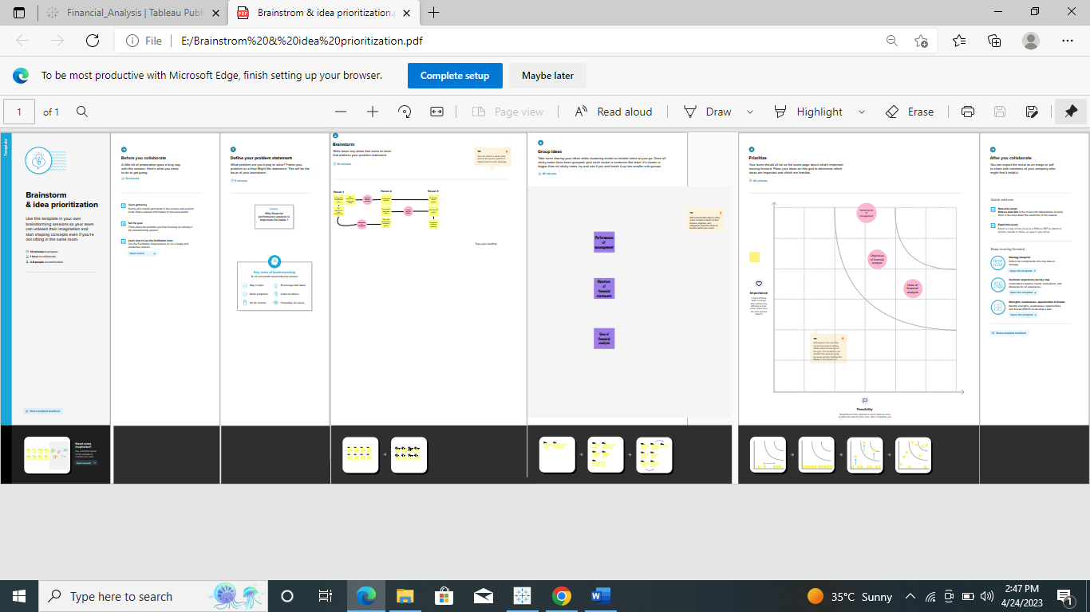

**||) Empathy map**

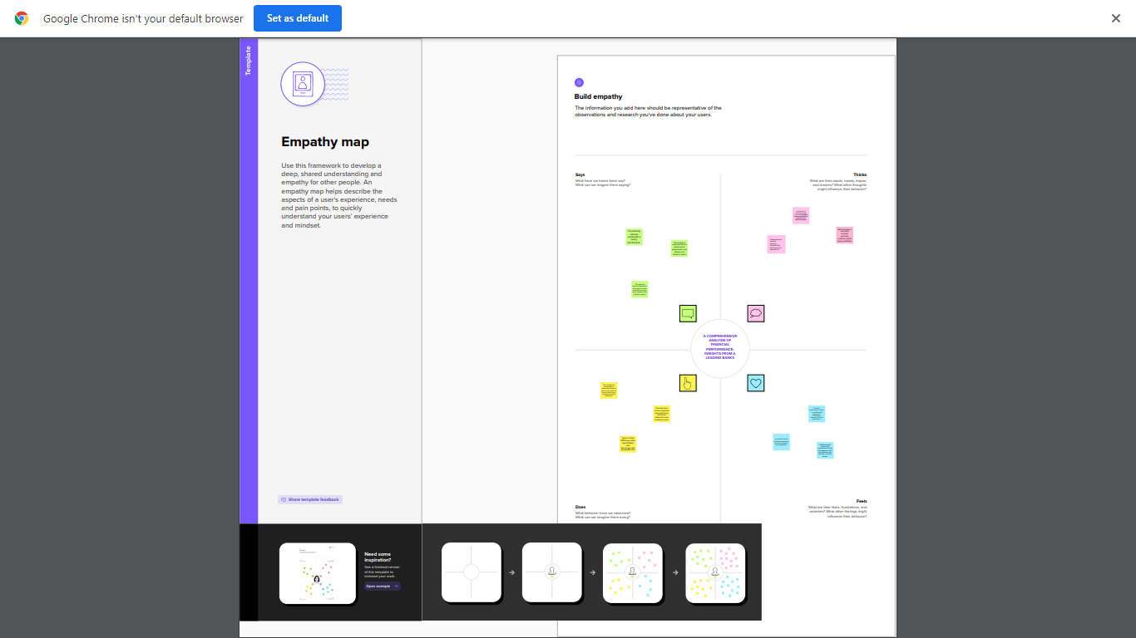

**3)RESULTS:**

**Dashboard**

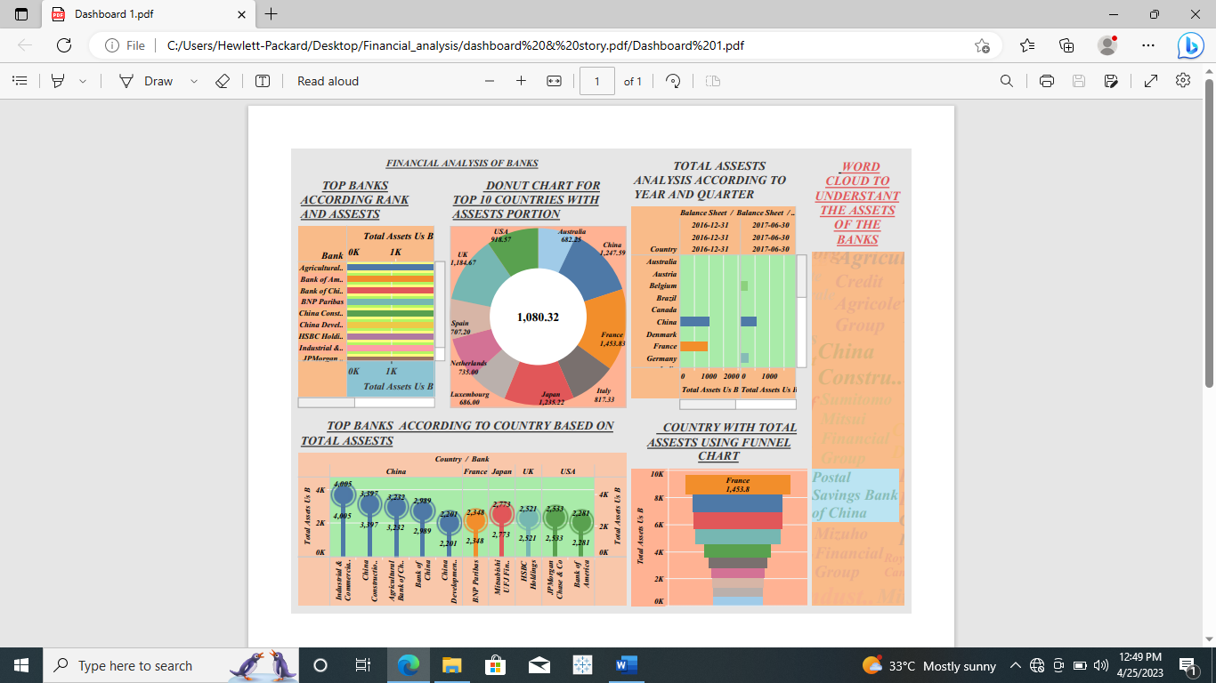

**Story board**

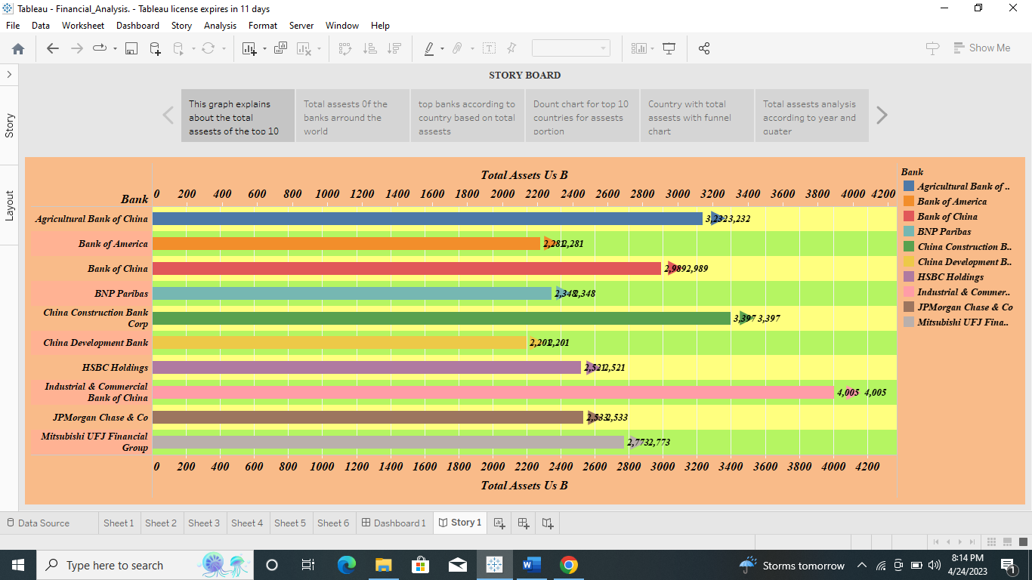

Publishing dashboard and storyboard to tableau public

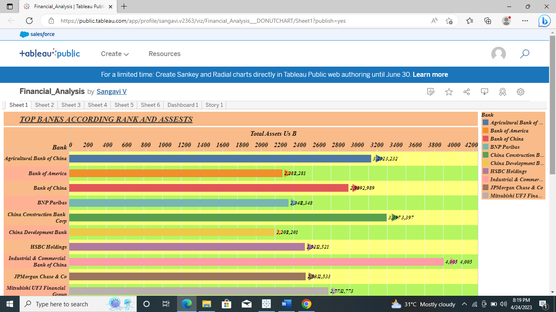

**4) |) ADVANTAGES:**

* The financial performance analysis provides financial information such as,
* The company's asset structure,
* asset liquidity,
* source of funds,
* debt level, and liability structure
* Thus, according to financial tools to analyze each part of financial statements is useful for **avoiding financial risks**.

**||) DISADVANTAGES:**

disadvantage of using financial statements for decision making is that the data and figures are based on the market at that given time. Depending on the market, it may change quickly, so executives should not assume that the numbers from a previous financial statement will remain the same or increase. Just because a company has sold 5 million copies of a product during one year does not guarantee it will sell the same amount or more. It may sell much less if a competitor releases a similar product.

**5)APPLICATION:**

* Customer Segmentation. ...
* Fraud management & prevention. ...
* Risk modeling. ...
* Identifying the main channels of transactions (ATM withdrawal, credit/debit card payments) ...
* Customer Lifetime Value (LTV) ...
* Predictive analytics helps: ...
* Feedback management.

**6)CONCLUSION:**

In this project we are analysis the bank related data and able to extract some insights from the data using Business Intelligence tools. Extract the Insights from the data and put the data in the form of visualizations, Dashboards and Story we employed Tableau tool.

**7) FUTURE SCOPE:**

Analyze financial ratios to assess profitability ,solvency ,working capital management ,liquidity ,and effectiveness.